How to make a SMB server using Raspberry PI

This document will guide a beginner understand how to create a server using Raspberry pi and the necessary background knowledge one should have before someone starts the project.

The videos and links shown below helps even an “amateur” understand the very basics of how to proceed.

**Basics to understand before starting this project:**

Introduction to File Sharing between machines:

<https://www.youtube.com/watch?v=uFQhawnWOrI>

Ownership in a Linux File system:

<https://www.youtube.com/watch?v=P3DHLMEU5lo>

Chronjob:

<https://www.youtube.com/watch?v=rErAOjACT6w>

**By following the below given links and videos one can easily implement SMBServer on the Raspberry pi.**

**Websites**:

The below websites provide a basic very clear explanation on how to proceed:

<https://magpi.raspberrypi.org/articles/samba-file-server>

<https://raspberrytips.com/raspberry-pi-file-server/>

Video:

<https://www.youtube.com/watch?v=0vEK4A8FOX0>

**Connect to the SMB Server on Raspberry pi using a Ubuntu 18.04 Machine can be done as shown in the below picture**

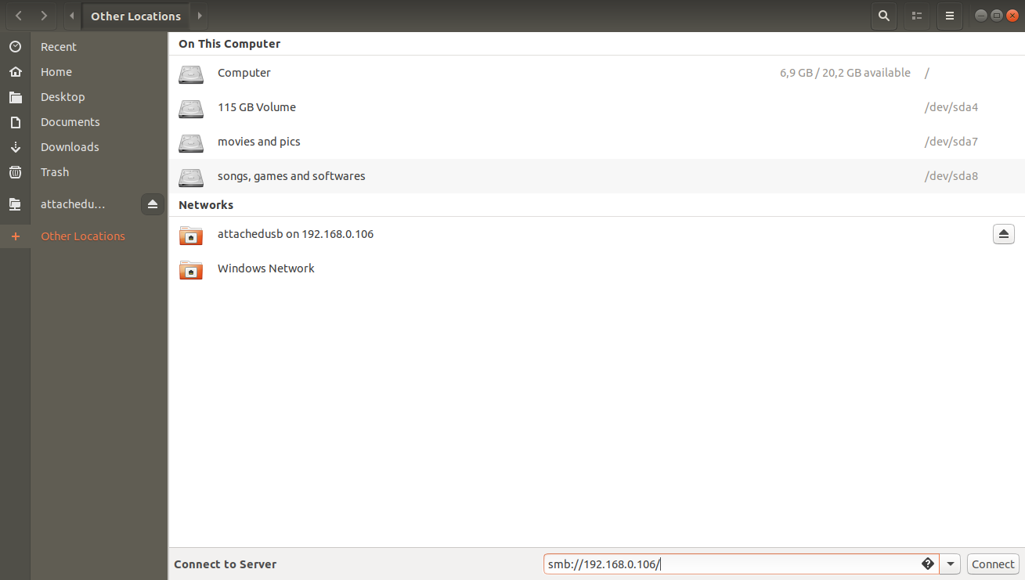

**Once you have implemented your SMB server in Raspberry pi, Raspberry pi goes offline from the Wi-Fi connection at regular intervals of time.**

**Solution:**

Due to this reason we need to set verify the network connection in the PI at regular intervals of time.

1. It can be seen that “**ifconfig**” command shows 3 interfaces(Physical Interfaces present on Raspberry PI) and we are bothered only about “wlan0” which represents Wi-Fi connection interface.

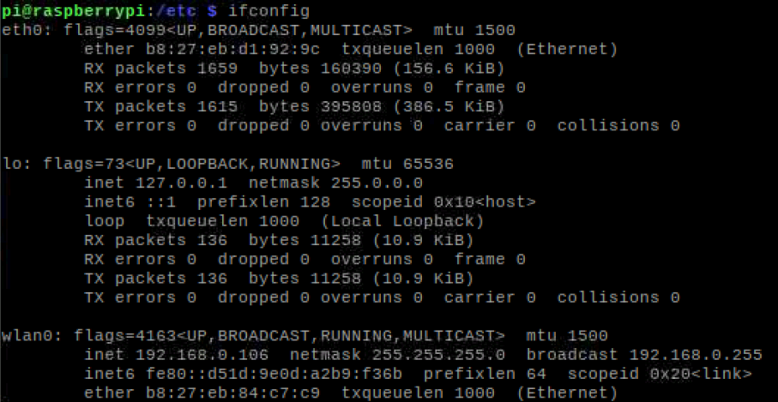

1. Enter the following commands:

**cd /etc/network**

**Sudo vim interfaces**

1. Add the following lines for Wi-fi. If you have some other “interface name” other than “wlan0”. Replace wlan0 with that interface name accordingly.

To know more about interfaces file, please visit: <https://linuxconfig.org/etcnetworkinterfacesto-connect-ubuntu-to-a-wireless-network>

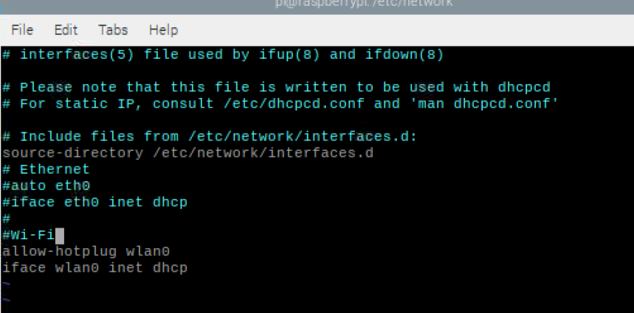

1. One should create a bash script (using vim, gedit, etc ...) to check the wifi connectivity for a regular intervals of time. This is provided in the following link:

<https://raspberrypi.stackexchange.com/questions/13473/connected-to-the-internet-but-cant-ssh-or-ping>

**#!/bin/bash**

**#Script to check the network connection**

**#Check network connection**

**if /sbin/ifconfig wlan0 | grep -q "inet addr:" ; then**

**#Connection is good; do nothing**

**echo "$(date "+%D [%H:%M:%S]") Connection is up"**

**else**

**echo "$(date "+%D [%H:%M:%S]") Network connection down. Attempting to reconnect..."**

**sudo /sbin/ifup --force wlan0**

**fi**

1. Save the above script as as network-monitor.sh
2. Make it file executable using “chmod” command

**Sudo chmod +x ./network-monitor.sh**

1. Run the net work-monitor.sh executable now

**./network-monitor.sh**

1. **Almost done!!! Now this script needs to be run at regular intervals of time to keep the Wi-Fi network in check. This can be done by using chrontab.**

<https://www.youtube.com/watch?v=rErAOjACT6w>